

|  |  |  |
| --- | --- | --- |
| Mathematics Department | |  |
| Course: A1MAA | |
| **Topic Title:** Test 3 - Mensuration, similar figures and scale factors | |
| Mensuration, similar figures and scale factors  Student Name:_____________________________________ | Date: ____________ | | |
| Special Instructions: **Calculator Allowed** | Time Allowed: 50 minutes | | |
| Formulae Sheet and 1 A4 page of notes allowed. | Marks: / 45 | | |
| Show all working. | | | |

**Question 1 [3 marks]**

A ladder has its base on level ground and its top resting against a vertical wall. If the ladder is 7 metres in length and reaches 5.8 metres up the wall, how far, to the nearest cm is the foot of the ladder from the base of the wall?

**Question 2 [3 marks]**

A rod of length 1 metre just fits inside a cylindrical container of base radius 25cm.

Determine the height of the container, to the nearest cm.

**Question 3 [1,3,6:10 marks]**

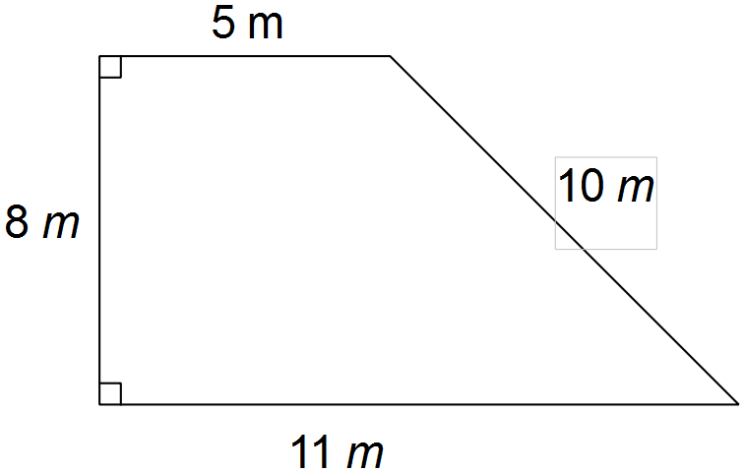

(a)

Dan wants to fence this area of his backyard.

(i) How many metres of fencing will he need?

Dan also wants to improve that soil with compost. He intends adding one bag for every 20 m2.

(ii) How many bags of compost will he need?

(b) Calculate, stating your answers correct to two decimal places, where appropriate:

(i) the area **and** (ii) the perimeter of the following figure.

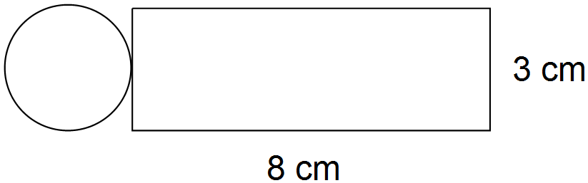

**Question 4 [4,4,3,4: 15 marks]**

(a) The top of a water tank is drawn below. It is made from three sheets of material which are 80 cm wide. One sheet is rectangular and the other two are semi-circular.

Calculate the area of the top of the tank.

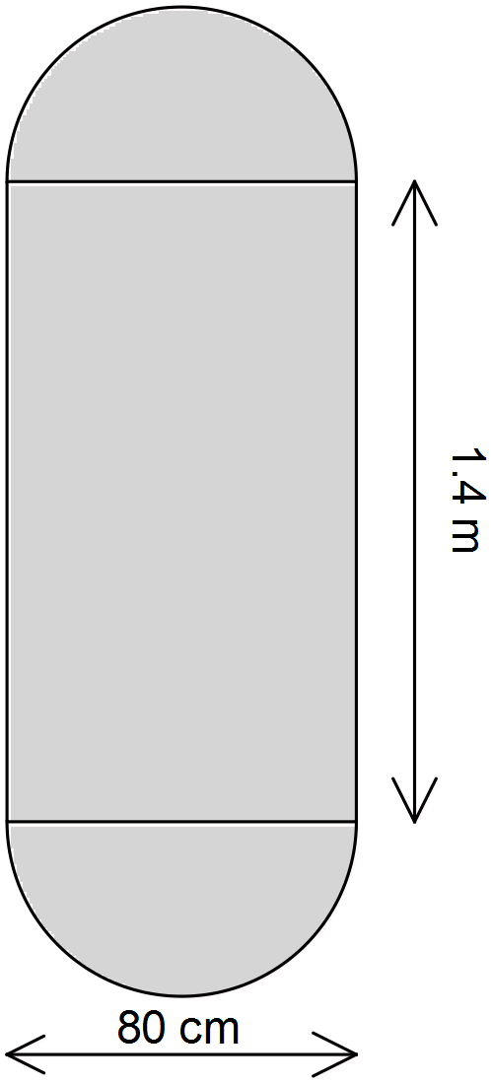

(b) Su Lin and Sami discovered that their television needed to be between 46” and 55”.

The size of televisions refers to the lengths of the diagonals of the rectangular screens. (4 marks)

(i) State the minimum size in centimetres. [1” is approximately 2.5 cm]

(ii) One television that Su Lin and Sami considered was 85 cm wide and 70 cm high. Determine the size (in cm) of this television.

Comment on the suitability of this television for Su Lin and Sami.

(c) At Millie’s birthday party three of the children filled their party hats with sand. Each of the cone-shaped

hats was 10 cm wide and 15 cm high. How much sand did each hat hold?

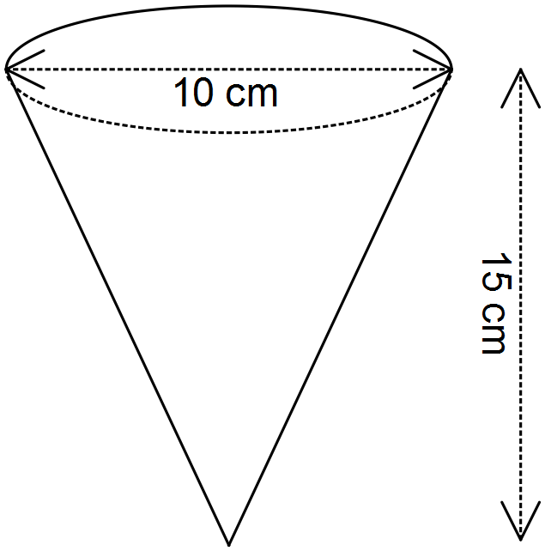

(d) A wheelchair ramp in the shape of a triangular prism is pictured below. It will be painted on all faces.

Determine the total surface area of the ramp.

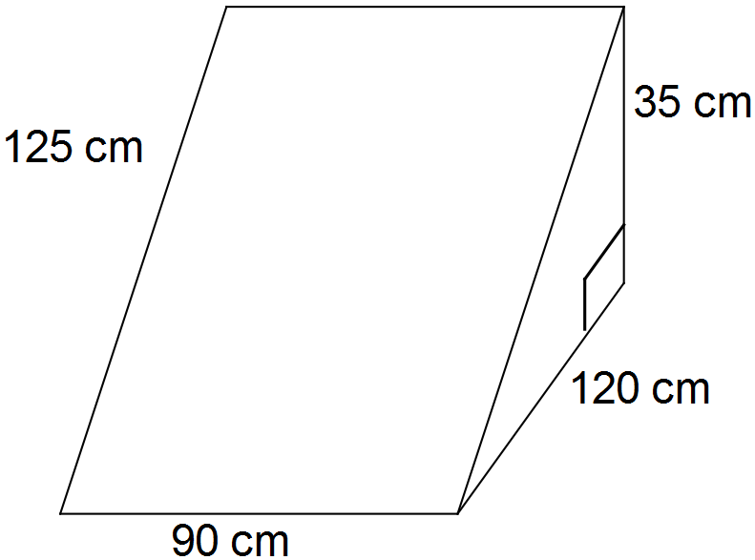

**Question 5 [2,2,1,3:8 marks]**

Jan has baked a Christmas cake which is cylindrical in shape, 30 cm wide and 8 cm high.

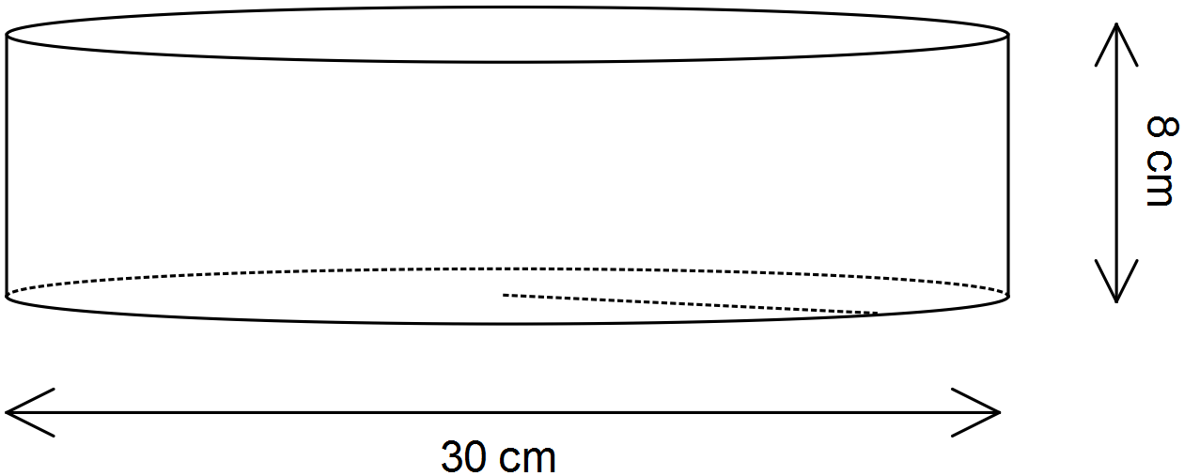

D:\IMAGES.TIF\FOOD\BAKED\FODBK093.TIF

(a) Jan wishes to place paper trimming right around the outside of the cake. Her trimming is 8 cm wide. What is the minimum length that it should be?

(b) Jan is going to ice the cake on the top and around the outside (not on the bottom).

(i) How much of the cake will need to be iced?

(ii) If Jan needs 100 g of sugar for each 1000 cm2 of icing that she makes, how much sugar will she need?

(c) Jan is going to divide the cake up evenly between the eight people at the Christmas lunch. How much

cake will each person get?

[Assume the thickness of the icing does not need to be considered.]

**Question 6 [3,3:6 marks]**

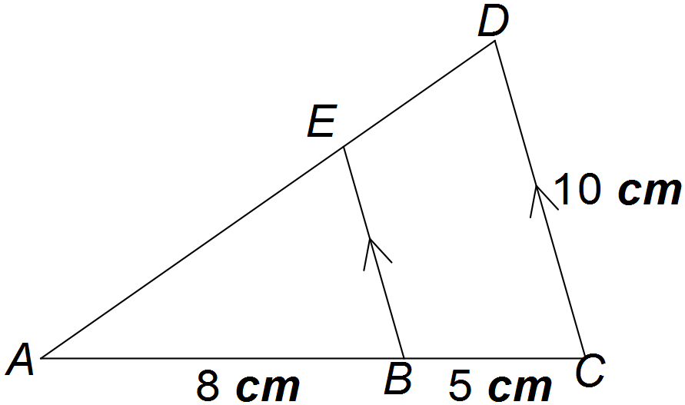

(a) Prove that ΔEAB ~ ΔDAC.

(b) Determine the length of EB.